Product Intelligence Platform — Architecture & Layer Guide
Nov 1, 2026 · @Mansi

Overview
The platform turns raw product events into metrics, experiment verdicts, risk alerts and written summaries, then shows them on a public dashboard. It has 8 layers. Layers 1–7 run as Python once a day; layer 8 is the website, which only reads finished results.
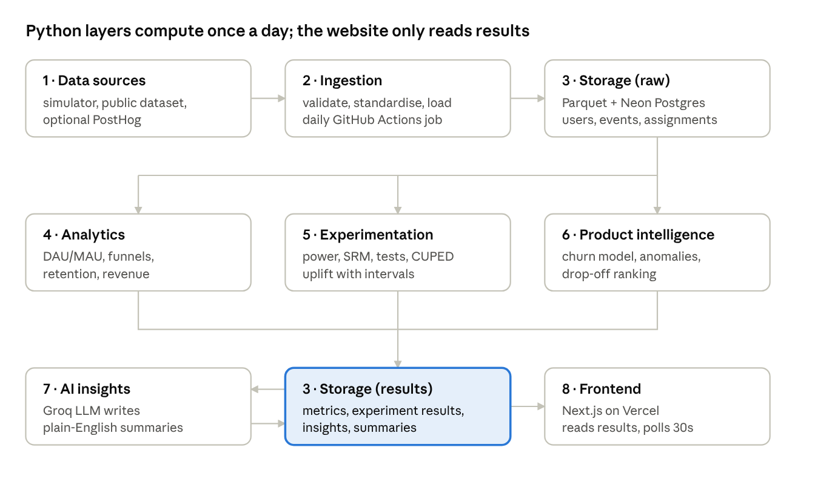
whole platform · 8 layers
Read it top to bottom. Events are created (1), cleaned and loaded (2) and stored raw (3). Three analysis layers (4, 5, 6) each read the raw data independently and write their outputs to result tables (3). The AI layer (7) reads those results, writes summaries back, and the frontend (8) displays everything.
Why it's split this way:
- Separation of compute and serving. Expensive work happens once, offline. Visitors never trigger heavy computation, so the site stays fast and free.
- Each layer has one job and one output table. You can rebuild or test any layer without touching the others.
- Storage is the contract between layers. Layers never call each other directly; they read and write agreed tables. This is how real data platforms are organised.
Layer | Main question it answers | Writes to
1 Data sources | What happened in the product? | Parquet files
2 Ingestion | Is the data valid and in one standard shape? | events, users, assignments
3 Storage | Where does everything live? | (the tables themselves)
4 Analytics | How is the product doing? | daily_metrics, funnel_daily, retention_cohorts
5 Experimentation | Did the change cause an improvement? | experiment_results
6 Product intelligence | What's going wrong, and who might leave? | insights, churn_scores
7 AI insights | What does it all mean, in plain words? | insights (summary rows)
8 Frontend | How do people see it? | nothing (read-only)

One day in the life of the platform
Everything below happens in a single GitHub Actions run, once a day (for example 02:00 UTC), and takes a few minutes. The website keeps serving yesterday's results until the run finishes.
- Trigger. GitHub Actions starts daily.yml on its cron schedule.
- Generate (Layer 1). The simulator creates yesterday's users and events, including any planted effects active that day.
- Validate and load (Layer 2). Events are checked against the schema, bad rows go to a rejects file, and good rows are written to Postgres.
- Store (Layer 3). Raw events are appended to events; new users go to users; experiment assignments go to assignments.
- Compute metrics (Layer 4). Yesterday's DAU, funnel, retention and revenue numbers are calculated and written to the metric tables.
- Evaluate experiments (Layer 5). Every running experiment is re-analysed: SRM check, significance test, uplift and confidence interval.
- Find problems (Layer 6). Anomaly detection runs on the new metrics; churn scores are refreshed (the model itself is retrained weekly).
- Write summaries (Layer 7). The day's numbers go to the LLM, which returns a short plain-English summary; it is checked and stored.
- Serve (Layer 8). The next visitor to the dashboard sees the new results. Nothing on the website had to run.
If any step fails, the run stops, GitHub emails you, and the website keeps showing the last good results. That's a deliberate safety property of the design.

Layer 1 — Data sources
Job: produce product events — a record of every action a user takes — in one standard format. Input: a config file (and optionally a public dataset). Output: one Parquet file of events per day.
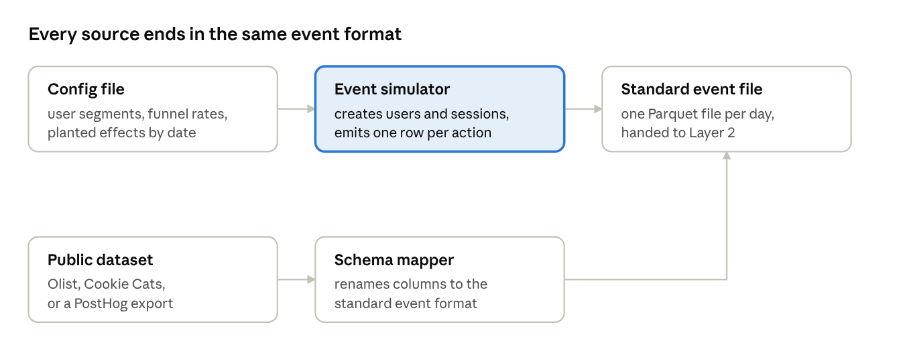
Layer 1 · data sources
The simulator is the main source. Public datasets and PostHog are optional extras that go through a mapper so they look identical to simulated events.
What an event looks like:
{"event_id": "e_81f2", "user_id": "u_10432", "session_id": "s_5521",
"event_name": "onboarding_completed", "timestamp": "2026-11-01T09:14:22Z",
"properties": {"device": "mobile", "country": "GB", "channel": "organic"},
"experiment_id": "exp_onboarding_v2", "variant": "B"}
How the simulator works, step by step:
- Create new users each day. The number follows a weekly pattern (fewer at weekends) plus random noise.
- Give each user attributes — device, country, acquisition channel — drawn from set proportions.
- Assign experiments. If an experiment is running, the user is hashed into control (A) or variant (B).
- Walk each user through the funnel. At each step (visit → signup → onboarding → first key action → trial → paid) a random draw decides whether they continue. The probability depends on their segment and their variant.
- Simulate returning visits. Each day, an active user's chance of coming back falls over time and rises with engagement. This creates realistic retention curves and churn.
- Apply planted effects. For example: variant B adds +3 percentage points to onboarding completion; on one chosen date, signups halve (a fake outage).
- Write the day's events to a Parquet file.
Why planted effects matter: you know the true answer, so you can prove that later layers find it. That turns "I ran a t-test" into "I validated my whole method."
Tech: Python, NumPy (random draws), Pandas, PyArrow (Parquet), a YAML config file.

Layer 2 — Ingestion & pipeline
Job: make sure only clean, correctly shaped data enters the database, and run the whole platform on a schedule. Input: the day's Parquet file. Output: rows in events, users and assignments, plus a rejects file and a run log.
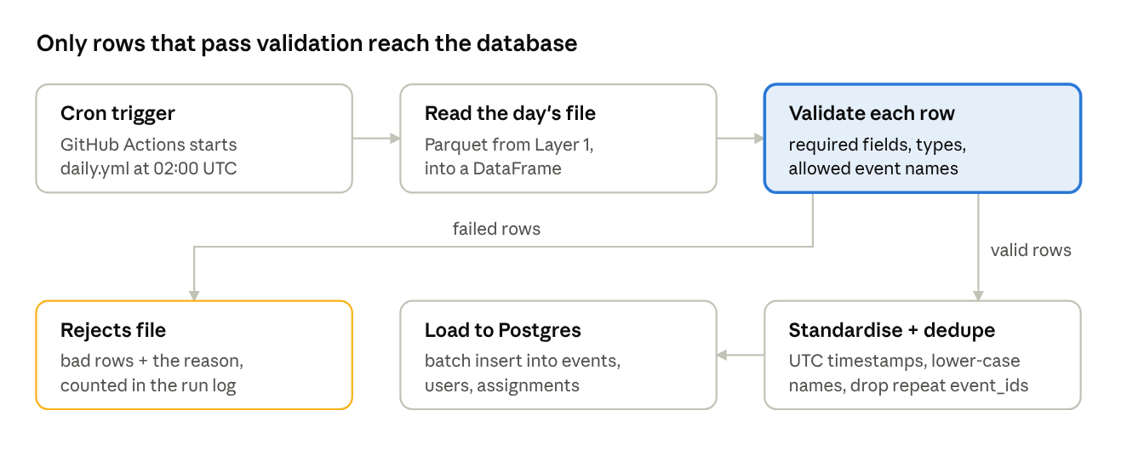
Layer 2 · ingestion & pipeline
Bad data is set aside with a reason, never silently dropped or loaded. The run log records how many rows passed and failed, so a sudden jump in rejects is visible.
What validation checks:
- Required fields are present: event_id, user_id, event_name, timestamp
- Types are right: timestamps parse, IDs are strings, properties is valid JSON
- event_name is in the allowed list (catches typos like sign_up vs signup)
- Timestamps are not in the future and not years in the past
- Each variant is one of the experiment's defined variants
What standardising does: converts every timestamp to UTC, lower-cases names, fills default property values, and removes duplicate event_ids. That last step makes the load idempotent: re-running the same day twice doesn't double-count anything.
The scheduler (daily.yml): a GitHub Actions workflow with a schedule: cron trigger. It installs Python, runs each layer's script in order, and reads the database password from GitHub Secrets. You can also trigger it by hand with workflow_dispatch when testing.
Tech: Pandas, Pydantic or Pandera (schema validation), psycopg or SQLAlchemy (loading), GitHub Actions.
Interview angle: idempotent loads, schema validation, and "fail loudly, keep serving the last good data" are standard data-engineering practices worth naming.

Layer 3 — Storage
Job: hold all data in two zones — raw facts and computed results — so every layer knows where to read and write. Input: rows from Layer 2 and results from Layers 4–7. Output: tables that any layer can query.
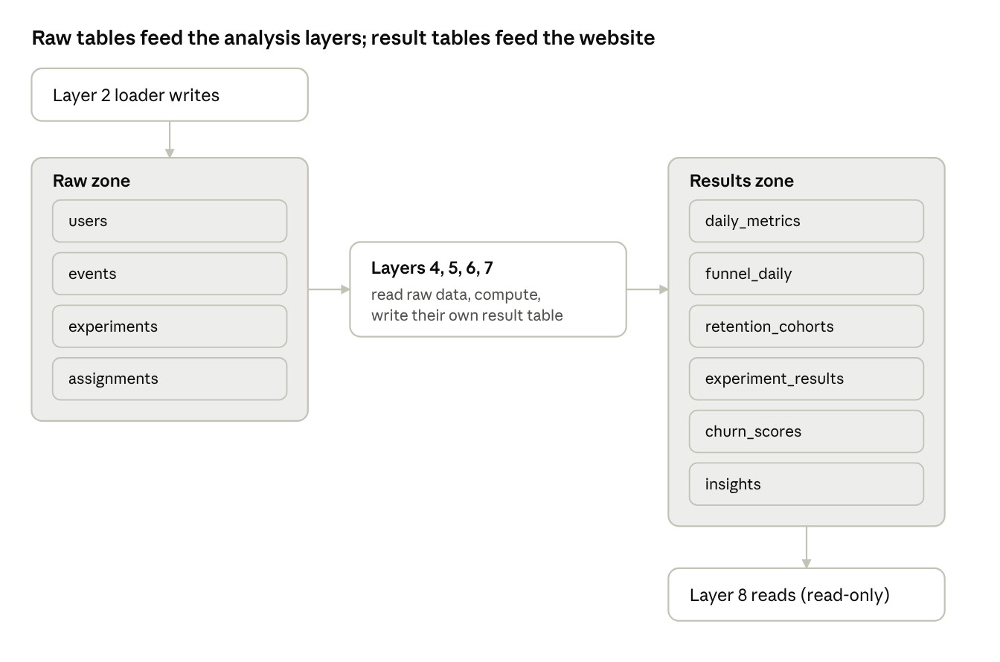
Layer 3 · storage zones and tables
The raw zone is append-only: facts are never changed after they're loaded. Each result table is owned by exactly one layer, which overwrites its own rows on each run.
The tables:
Table | Zone | One row is… | Written by
users | Raw | a user, with signup date, device, country, channel | Layer 2
events | Raw | one action by one user at one time | Layer 2
experiments | Raw | an experiment's design: hypothesis, metric, MDE, dates | You (config)
assignments | Raw | which variant a user got in an experiment | Layer 2
daily_metrics | Results | one metric on one day (e.g. DAU = 4,210) | Layer 4
funnel_daily | Results | users reaching each funnel step, per day and segment | Layer 4
retention_cohorts | Results | share of a signup week still active after N days | Layer 4
experiment_results | Results | one metric's result for one experiment on one day | Layer 5
churn_scores | Results | a user's predicted churn probability | Layer 6
insights | Results | one finding (anomaly, drop-off, summary) with evidence | Layers 6, 7
Two storage engines, two purposes:
- Neon Postgres (cloud) holds what the website needs: all result tables, plus raw tables if they fit the free size limit.
- Parquet files + DuckDB (local and in CI) hold the full raw event history cheaply. DuckDB can run SQL directly on Parquet files, which is fast for heavy analysis in notebooks.
Design choices worth explaining: indexes on events(timestamp), events(user_id) and events(event_name); a separate read-only database user for the website; result tables small enough that every dashboard query returns in milliseconds.
Tech: PostgreSQL (Neon), DuckDB, Parquet, SQL migrations in schema.sql.

Layer 4 — Analytics
Job: answer "how is the product doing?" with standard product metrics. Input: raw events and users. Output: daily_metrics, funnel_daily, retention_cohorts.
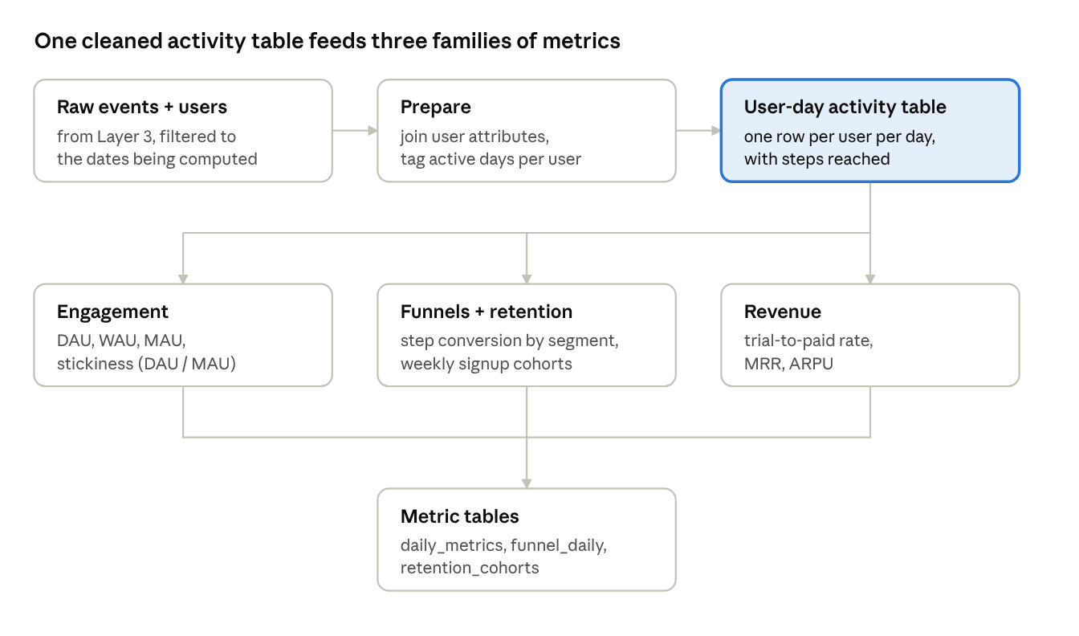
Layer 4 · analytics
The key step is building one intermediate table — one row per user per day, saying whether they were active and which funnel steps they reached. Every metric is then a simple group-by on that table, which keeps definitions consistent.
The metrics, in plain words:
Metric | Definition | Why it matters
DAU / WAU / MAU | Distinct users active in the last 1 / 7 / 30 days | Size of the engaged audience
Stickiness | DAU ÷ MAU | How often monthly users come back; 20%+ is healthy for many apps
Funnel conversion | Share of users at step N who reach step N+1 | Shows where users get stuck
Cohort retention | Of users who signed up in week W, share active on day 1, 7, 14, 30 | Whether the product keeps people
Trial-to-paid | Share of trials that convert to a paid plan | Core revenue lever
MRR | Sum of monthly subscription revenue | Business size
ARPU | Revenue ÷ active users | Value per user
Segments: every metric is also computed by device, country and acquisition channel, so the dashboard can filter. Comparing segments is often where insights come from (e.g. "mobile users drop off at onboarding twice as often").
Checking it works: the funnel should show the planted outage as a sharp one-day dip in signups, and the retention table should match the return probabilities you set in the simulator config.
Tech: SQL (run in Postgres or DuckDB) for the heavy aggregations, Pandas for reshaping, pytest for checks like "DAU is never greater than MAU".

Layer 5 — Experimentation engine
Job: decide whether a product change caused an improvement, not just whether numbers moved. Input: experiments, assignments, events. Output: experiment_results. This is the layer that shows the most data science skill.
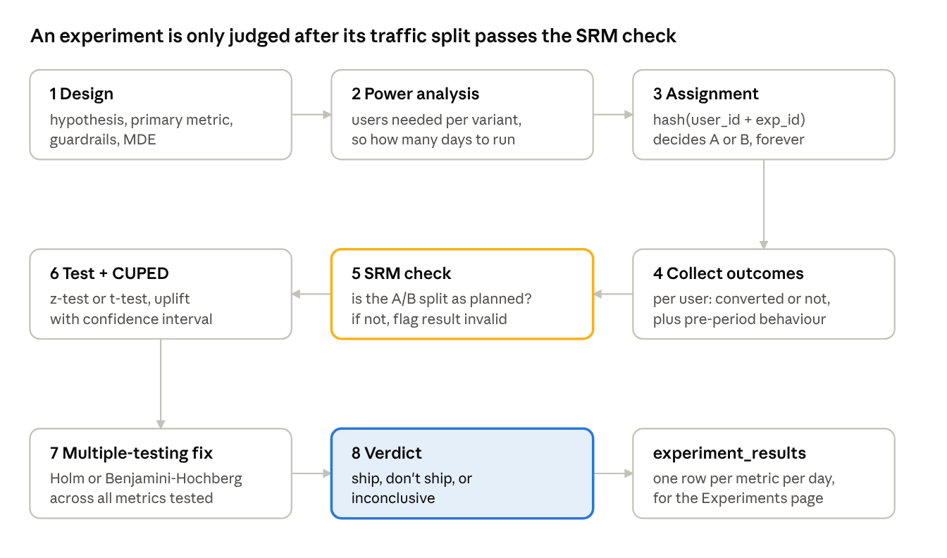
Layer 5 · experiment lifecycle, 8 steps
Steps 1–3 happen before the experiment starts; steps 4–8 re-run every day while it's live. Results only count once the planned sample size is reached.
Each step explained:
- Design. Write the hypothesis ("a shorter onboarding raises completion"), choose one primary metric, add guardrail metrics that must not get worse (e.g. trial-to-paid), and set the minimum detectable effect (MDE) — the smallest lift worth detecting.
- Power analysis. Given the baseline rate, MDE, significance level (5%) and power (80%), calculate users needed per variant. Divide by daily traffic to get how many days to run.
- Assignment. Hash user_id + experiment_id into a number from 0–99; below 50 is A, otherwise B. The same user always gets the same variant, and different experiments split independently.
- Collect outcomes. For each assigned user: did they convert on the primary metric? Also record their behaviour before the experiment (needed for CUPED).
- SRM check. A chi-square test asks whether the A/B split matches the plan (e.g. 50/50). A mismatch means something is broken — a bug, a bot, a redirect — so results can't be trusted.
- Statistical test + CUPED. A two-proportion z-test (for rates) or Welch's t-test (for averages) gives a p-value and a confidence interval for the uplift. CUPED adjusts each user's outcome using their pre-period behaviour, which removes noise and narrows the interval.
- Multiple-testing correction. Testing many metrics raises the chance of a false winner. Holm or Benjamini–Hochberg adjust the p-values to compensate.
- Verdict. Ship if the primary metric's interval is above zero and no guardrail is significantly worse; don't ship if it's below zero; otherwise inconclusive.
The peeking trap: if you check results every day and stop the first time p < 0.05, false positives rise well above 5%. The project includes a simulation (run many A/A tests with daily peeking) that shows this, which is a strong talking point.
Validation: the engine must recover the planted +3-point lift within its confidence interval, find no effect in an A/A test, and flag the deliberately broken experiment through the SRM check.
Tech: SciPy (chi-square, t-test), statsmodels (proportion z-test, power analysis, multiple-testing correction), NumPy, hashlib.

Layer 6 — Product intelligence
Job: find problems and risks automatically, so nobody has to stare at charts. Input: raw events plus Layer 4's metrics. Output: churn_scores and rows in insights.
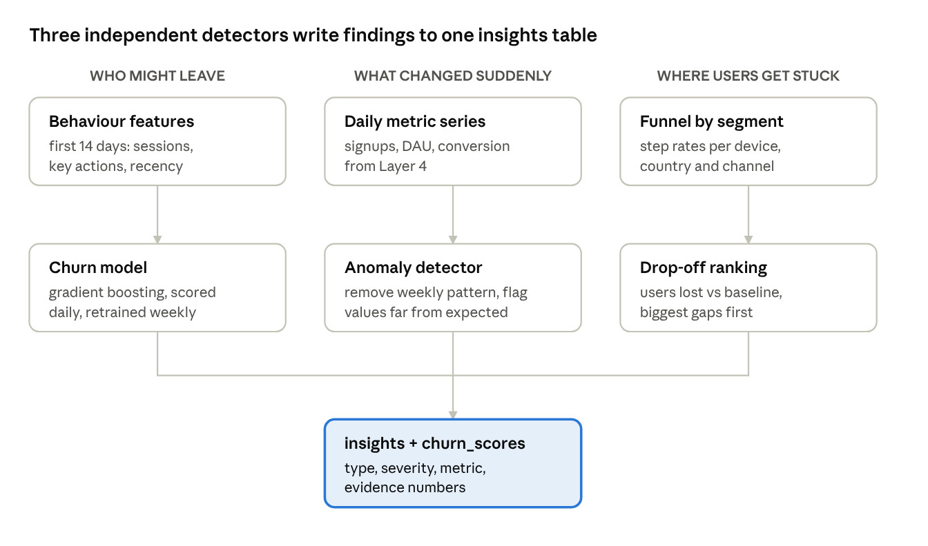
Layer 6 · three detectors
The three detectors don't depend on each other. Each writes findings in the same shape — type, severity, affected metric, and the numbers behind it — so Layer 7 and the dashboard can treat them uniformly.
Churn model (who might leave)
- Label: a user has churned if they're inactive for 14 days after their first 14 days.
- Features: sessions per week, days since last visit, key actions completed, onboarding finished or not, device, channel.
- Models: logistic regression as a baseline, then HistGradientBoostingClassifier. Keep the simpler model if the gain is small.
- Evaluation: split by time (train on older signups, test on newer) so the model never sees the future. Report ROC-AUC, precision–recall, and a calibration plot (does "30% risk" really mean about 30% leave?).
- Explanation: permutation importance or SHAP shows which behaviours drive risk.
Anomaly detector (what changed suddenly)
- Daily metrics have a weekly rhythm, so first remove it (STL decomposition or comparing to the same weekday).
- Flag a day when the leftover value is more than about 3 standard deviations from normal.
- Must catch the planted outage, and shouldn't fire on ordinary weekends.
Drop-off ranking (where users get stuck)
- For each funnel step and segment, compare today's conversion with its own recent baseline.
- Rank by users lost (gap × traffic), not by percentage alone, so big segments with real impact come first.
Tech: scikit-learn, statsmodels (STL), SHAP (optional), Pandas.

Layer 7 — AI insights
Job: turn numbers into short, plain-English explanations and recommendations. Input: the day's results from Layers 4–6. Output: summary rows in insights.
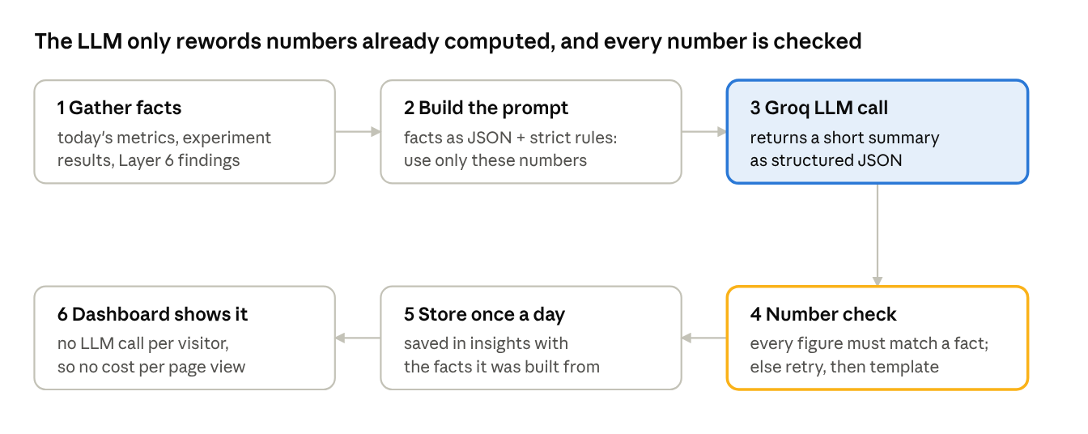
Layer 7 · AI insights pipeline, 6 steps
The LLM never calculates anything. All maths is done by Python in earlier layers; the LLM only explains it. That design is what keeps the summaries trustworthy.
Each step explained:
- Gather facts. Pull a small, fixed set: today vs. last week for key metrics, any running experiment's uplift and interval, and the top Layer 6 findings.
- Build the prompt. A template states the role ("you are a product analyst"), includes the facts as JSON, and sets rules: use only these numbers, say "inconclusive" when an interval crosses zero, keep it under 120 words, return JSON with headline, summary, recommendation.
- Call the LLM. One request to Groq's free API per summary type per day — a handful of calls a day, far inside free limits.
- Check numbers. Python extracts every number from the reply and confirms it appears in the facts. If not, retry once; if it still fails, fall back to a fixed template ("Signups fell 48% vs. last Tuesday").
- Store. Save the summary with the exact facts it was built from, so anyone can trace a sentence back to data.
- Display. The dashboard reads stored summaries. Visitors never trigger an LLM call, so traffic costs nothing.
Optional "Ask the data" box: a visitor's question goes to a Vercel API route. The LLM chooses one of a fixed list of safe, pre-written queries and fills in parameters (metric, date range, segment). It never writes raw SQL. Rate-limit it per visitor and cache common answers.
Tech: Groq API (OpenAI-compatible client), Python json + regex for checks, prompt templates kept in version control.

Layer 8 — Frontend & visualisation
Job: show everything clearly to recruiters, interviewers and anyone with the link. Input: result tables only. Output: the public website. It never writes data and never runs heavy computation.
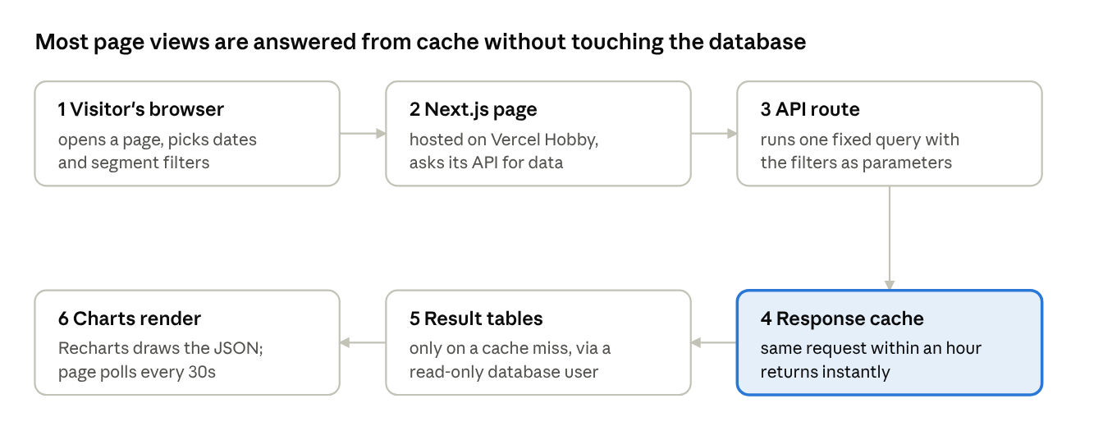
Layer 8 · one page request, 6 steps
Because results change only once a day, caching for an hour loses nothing and keeps database use tiny.
The pages:
Page | Shows | Main charts
Overview | Headline KPIs and today's AI summary | KPI tiles with sparklines, DAU line
Funnels | Step conversion and where users drop | Funnel bars, segment comparison
Retention | How well each signup cohort sticks | Cohort heatmap, retention curves
Experiments | Each experiment's design, status and verdict | Uplift with confidence interval, sample size progress, SRM status
Insights | Anomalies, drop-offs, churn risk, AI summaries | Annotated metric line, churn-risk distribution
About | How the platform works, data is simulated and why | Architecture diagram
The "live" feel without WebSockets:
- Pages poll their API every 30 seconds and update quietly if anything changed.
- A replay mode streams a recorded day of simulated events onto a live counter and event feed, so visitors see activity in motion.
Security basics: the database URL lives in Vercel environment variables, the website connects with a read-only database user, and API routes only run fixed, parameterised queries.
Tech: Next.js (App Router) + TypeScript, Tailwind CSS + shadcn/ui, Recharts, a Postgres client such as @neondatabase/serverless, Vercel Hobby hosting.

Glossary
Term | Meaning
A/A test | An experiment where both groups get the same thing; it should find no difference, so it checks your method
ARPU | Average revenue per user
Batch job | A script that runs on a schedule and processes data in one go, rather than continuously
Calibration | Whether predicted probabilities match reality (30% predicted risk ≈ 30% actually leave)
Cohort | A group of users who signed up in the same period
Confidence interval | The range of plausible values for the true effect; if it excludes zero, the effect is significant
CUPED | A way to reduce noise in experiments by adjusting for each user's behaviour before the test
DAU / WAU / MAU | Daily / weekly / monthly active users
Funnel | The ordered steps users take towards a goal, e.g. signup → onboarding → paid
Guardrail metric | A metric that must not get worse, even if the primary metric improves
Idempotent | Running the same job twice gives the same result as running it once
Leakage | When a model accidentally uses information from the future, making it look better than it is
MDE | Minimum detectable effect: the smallest change an experiment is designed to detect
MRR | Monthly recurring revenue
p-value | How surprising the observed difference would be if there were truly no effect
Parquet | A compressed, column-based file format that's fast for analytics
Peeking | Checking experiment results repeatedly and stopping early, which inflates false positives
Planted effect | A known change you build into the simulated data so you can check your analysis finds it
Power | The chance an experiment detects a real effect of a given size; 80% is the usual target
SRM | Sample ratio mismatch: the A/B split doesn't match the plan, which signals a bug
Stickiness | DAU ÷ MAU; how often monthly users return
STL | Seasonal-trend decomposition: splits a time series into trend, weekly pattern and leftover noise
Uplift | The difference between variant and control, as absolute points or a relative %

